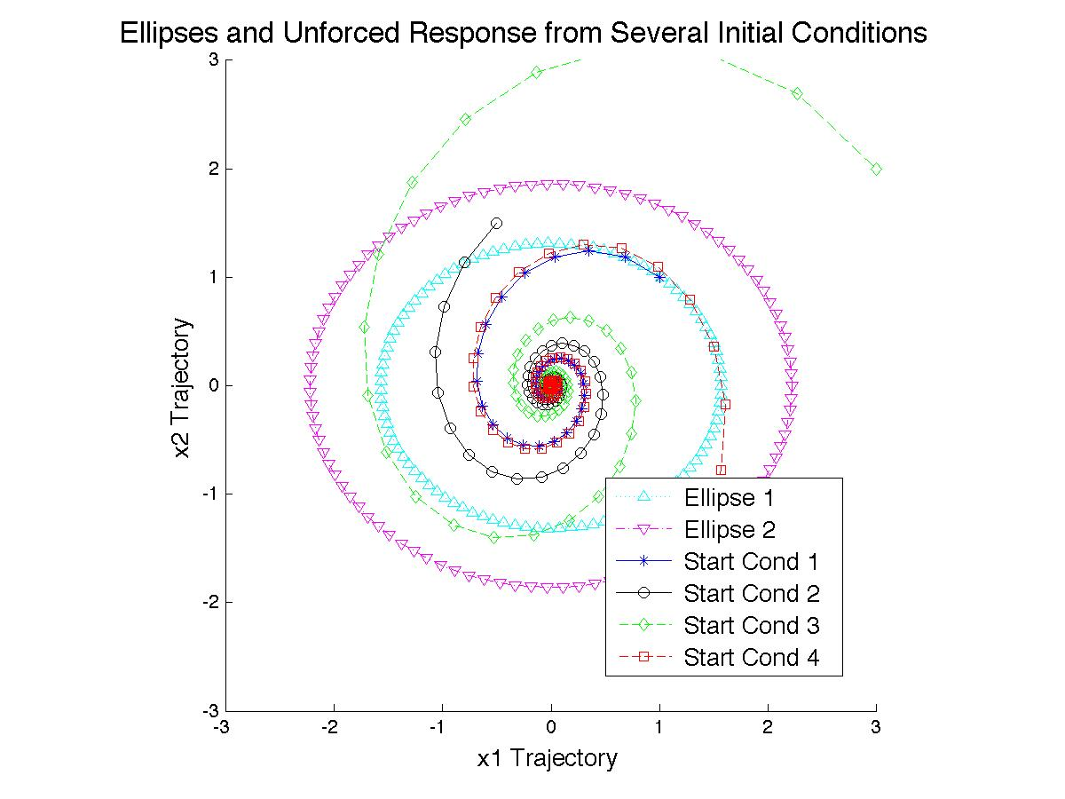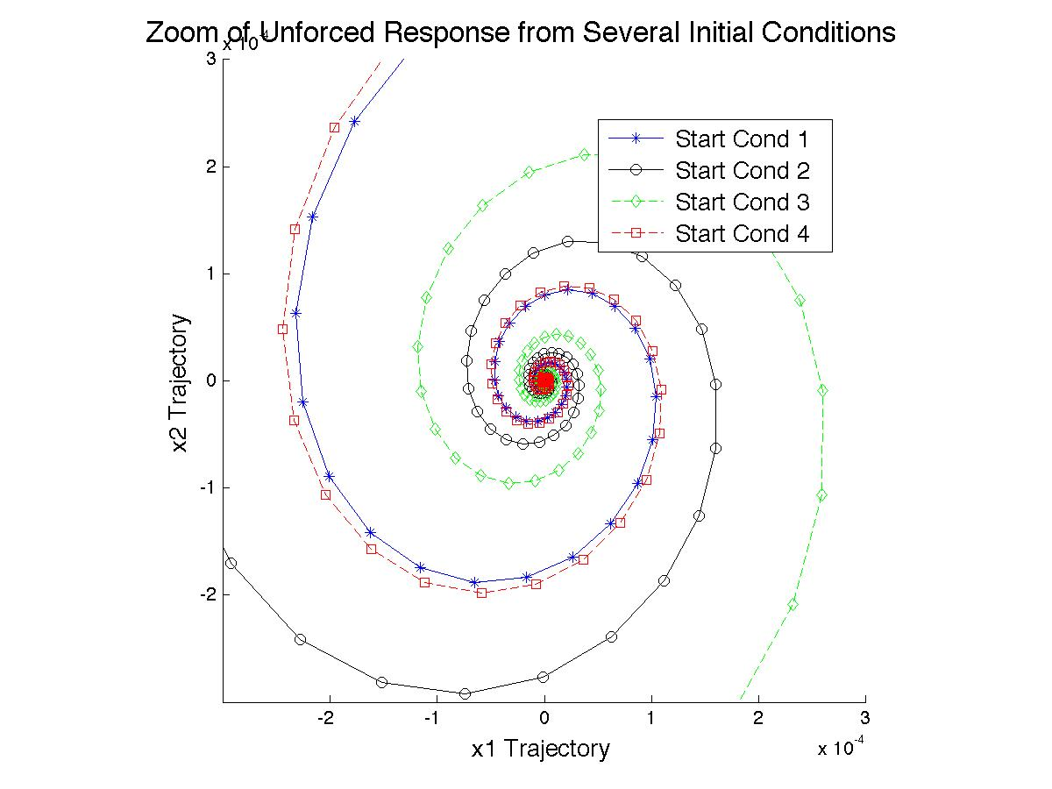

Note: scale is 10-4 for both axes on the “zoom” plot.

function HW13_EllipsePlots(zoom)

ABCSolve = [-2,14,0;-5,-3,7;0,-10,-4];

Pmake = eye(3)/ABCSolve*[-1,0,-1]';

P = [Pmake(1),Pmake(3);Pmake(3),Pmake(2)];

A = [-1,-5;7,-2];

B = [0;0];

I = -eye(2);

%First Ellipse, x'Px=1.

a1 = max((1/Pmake(1))^.5,(1/Pmake(3))^.5);

b1 = min((1/Pmake(1))^.5,(1/Pmake(3))^.5);

e1 = ((a1^2-b1^2)/a1^2)^.5;

[lat1, lon1] = ellipse1(0,0,[b1,e1]);

%Second Ellipse, x'Px=2.

a2 = max((2/Pmake(1))^.5,(2/Pmake(3))^.5);

b2 = min((2/Pmake(1))^.5,(2/Pmake(3))^.5);

e2 = ((a2^2-b2^2)/a2^2)^.5;

[lat2, lon2] = ellipse1(0,0,[b2,e2]);

%Create system, get points from several initial conditions, plot

sys = ss(A,[],[],[]);

x_start = [1,-.5,3,1;1,1.5,2,-2];

color = {'-b*','-ko','--gd','--rs',':c^','-.mv'};

figure;

title('\fontsize{16} Ellipses and Unforced Response from Several Initial Conditions');

xlabel('\fontsize{13} x1 Trajectory');

ylabel('\fontsize{13} x2 Trajectory');

axis square

axis([-3,3,-3,3]);

hold on;

plot(lat1,lon1,color{5},lat2,lon2,color{6});

t_span = 0:.05:10;

for jj = 1:4

[~,~,x] = initial(sys,x_start(:,jj),t_span);

plot(x(:,1),x(:,2),color{jj});

end

legend('\fontsize{13} Ellipse 1',...

'\fontsize{13} Ellipse 2',...

'\fontsize{13} Start Cond 1',...

'\fontsize{13} Start Cond 2',...

'\fontsize{13} Start Cond 3',...

'\fontsize{13} Start Cond 4',...

'Location','Best');

hold off;